APPLICATION FORM FOR ENLIGHT FUNDING
To support joint activities between the nine ENLIGHT universities in the area of teaching and learning, research and administration the University of Göttingen will fund, with support of the DAAD and BMBF, different projects for affiliates of the University of Göttingen and its ENLIGHT partners. Mobility schemes and resources for research, teaching or management projects in 2021 are eligible measures for funding in this call.
Both, new and established collaborations or projects are welcome for application. In any case, but especially when developing teaching and learning offers or exchange opportunities, it will be helpful to consult the International Office of the University of Göttingen (https://www.uni-goettingen.de/en/631929.html) in order to make use of existing agreements or to identify potential synergies with departments at ENLIGHT partner institutions.
Please note that only researchers, staff and students from the University of Göttingen (incl. University Medical Center Göttingen) can apply. Mobility funds for researchers, staff and students from the Universities of Bordeaux, Bratislava, Galway, Basque Country, Ghent, Groningen, Tartu and Uppsala to Göttingen must therefore be applied by a Göttingen researcher or staff member.
Please select the applicable funding option
ENLIGHT Mobility
Attendance – Short-term stay at ENLIGHT partner (3-5 days)
Attendance – Long-term stay at ENLIGHT partner (14 days to 3 months)
ENLIGHT Research, teaching or management project
Organisation – Assistant
Accommodation – ENLIGHT partner (3-14 days)

PERSONAL AND PROJECT DETAILS
Personal Details (Main applicant)
Full Name
Faculty & Department
Office Address
Email Address
Project Details
Title
Project Partner

Additional Documents
For mobility
Short-term stay (3-5 days)
- CV
- Event programme
Long-term stay (14 days to 3 months)
- CV
- Students: Letter of Recommendation from a postdoc or professor at the home institution
- Students: Letter of Invitation from a postdoc or professor at the host institution
- Cost projection
For research, teaching or management project
- Information on the applicant (short academic CV)
- Commitments of ENLIGHT participants
- Programme proposal, planned timeframe and venue
- Cost projection
- Project description (see below)

Project Description
Please describe your project, its ambition as well as the planned activities (Max. 4.000 characters).
(Field and/or thematic area, format, target audience, participants, …)
…
Please list your ENLIGHT partners and describe the quality of your cooperation (Max. 2.000 characters)
(Universities and departments involved, past cooperation, synergies, …)
…
Please describe how your project relates to one of ENLIGHT’S five flagship challenges (Max. 2.000 characters)
(Targeted challenges, cross-linking to core actions, …)
…
Please describe the long-term goals and sustainability of the cooperation (Max. 2.000 characters)
(Long term vision, pursuing collaborations, added value of the project, …)
…

SUBMISSION DEADLINE AND ADDRESS
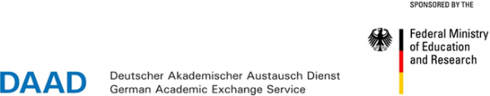
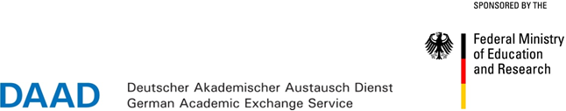
Please submit all documents to enlight@uni-goettingen.de.

