UBx Call for Applications - ENLIGHT Education & Research Initiatives
Application Form
University of Bordeaux

Application

General information
UBx applicant
Full name of the main applicant:
Email:
Position of the main applicant:
Research unit/department:

Other UBx staff involved in the project:

Partners involved
Partner university 1:
Full name of the applicant:
Position of the applicant:
Faculty/department:
Email:

Partner university 2:
Full name of the applicant:
Position of the applicant:
Faculty/department:
Email:

Project description
Please describe your project, its ambition as well as the planned activities – Max. 2 pages:

Main field:
Education ☐
Research & innovation ☐

History of the collaboration with the partners:
New collaboration ☐
New orientation in existing partnership ☐
New project within an existing partnership ☐

Project summary (objectives of the project, context of the collaboration, synergies between research and education areas if any, target audience, etc.) – 4500 ch. max.:

Needs analysis & innovative and strategic aspects of the project – 4500 ch. max.:

Expected impact & results (expected outcomes and consistency with UBx/ENLIGHT priorities, next steps for the collaboration, European/International call identified (if any) & deadline foreseen) – 4500 ch. max.:

Communication and dissemination strategy – 2500 ch. max:

Budget
Requested amount:
Please describe the planned activities (eligible for funding – see call description):
Economic model after the end of the seed-funding period:
Are your partners also providing funding for this project?
Yes ☐
Please indicate for what purpose:
No ☐

Additional information/comments (optional)

Name and signature of the Head of Department/Research unit:
Date:

ANNEX I
ENLIGHT partners & contacts

University of the Basque Country: enlight@ehu.eus
University of Comenius (Bratislava): enlight@uniba.sk
University of Galway: enlight@nuigalway.ie
University of Ghent: enlight@ugent.be or rise@ugent.be (for R&I initiatives)
University of Göttingen: enlight@uni-goettingen.de
University of Groningen: enlight@rug.nl
University of Tartu: enlight@ut.ee
University of Uppsala: enlight@uu.se
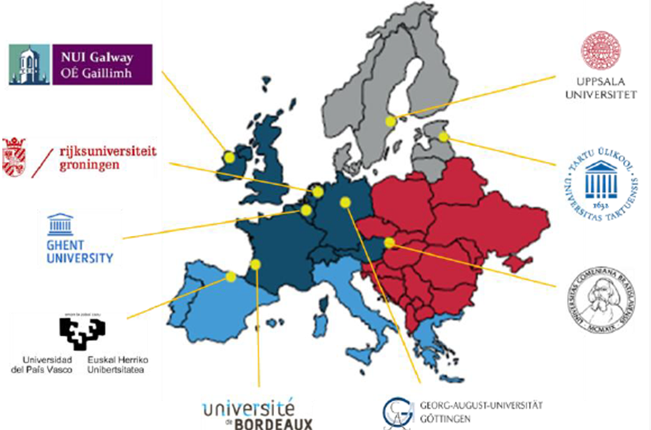

Add sections if needed

